ECE466 Lab Report

Lab 1 Traffic Characterization

Prepared by:

|  |  |  |
| --- | --- | --- |
| Name | Xiaoyang Guo | Xiao Tang Wang |
| Student Number | 999578513 | 999523029 |
| Date | Jan 30 2017 | |

# **Part 1. Poisson Traffic**

## **Exercise 1.1 Scaling Poisson traffic arrivals**

Consider a packet arrival pattern of a flow, where all packets have a constant size of 100 Bytes and where packet arrivals follow a Poisson process. The average traffic rate of the flow is 1 Mbps. The file poisson1.data contains a traffic trace of the data. The file has three columns: Column 1: Packet number Column 2: Timestamp (in milliseconds) Column 3: Packet size (in bytes).

• Verify the measured mean bit rate of the flow with the target rate, by calculating the mean and the variance of the times between consecutive arrival events. Compare the values with the theoretically expected values.

**Theoretically expected values:**

**Bit rate = 1Mbps**

**Arrival time = 800μs**

**Measured values:**

**Mean of time between consecutive arrival events = 799.5115μs**

**Variance of time between consecutive arrival events = 6.4054e+05**

**Mean bit rate = 1.0006Mbps**

• Plot 1: Generate a vector with 100 elements. Each element stores the number of

bytes from the Poisson trace that arrive in a time period of 1 second.

• Plot 2: Generate a vector with 100 elements. Each element stores the number of

bytes from the Poisson trace that arrive in a time period of 100 milliseconds,

beginning at a randomly selected start time.

• Plot 3: Generate a vector with 100 elements. Each element stores the number of

bytes from the Poisson trace that arrive in a time period of 10 milliseconds, beginning

at a randomly selected start time.

• Plot the content of the vectors in three separate graphs, with the time intervals on the

x-axis, and the number of bytes on the y-axis. The data points should be depicted as

vertical bars (e.g., using the MATLAB function `bar()’ ).

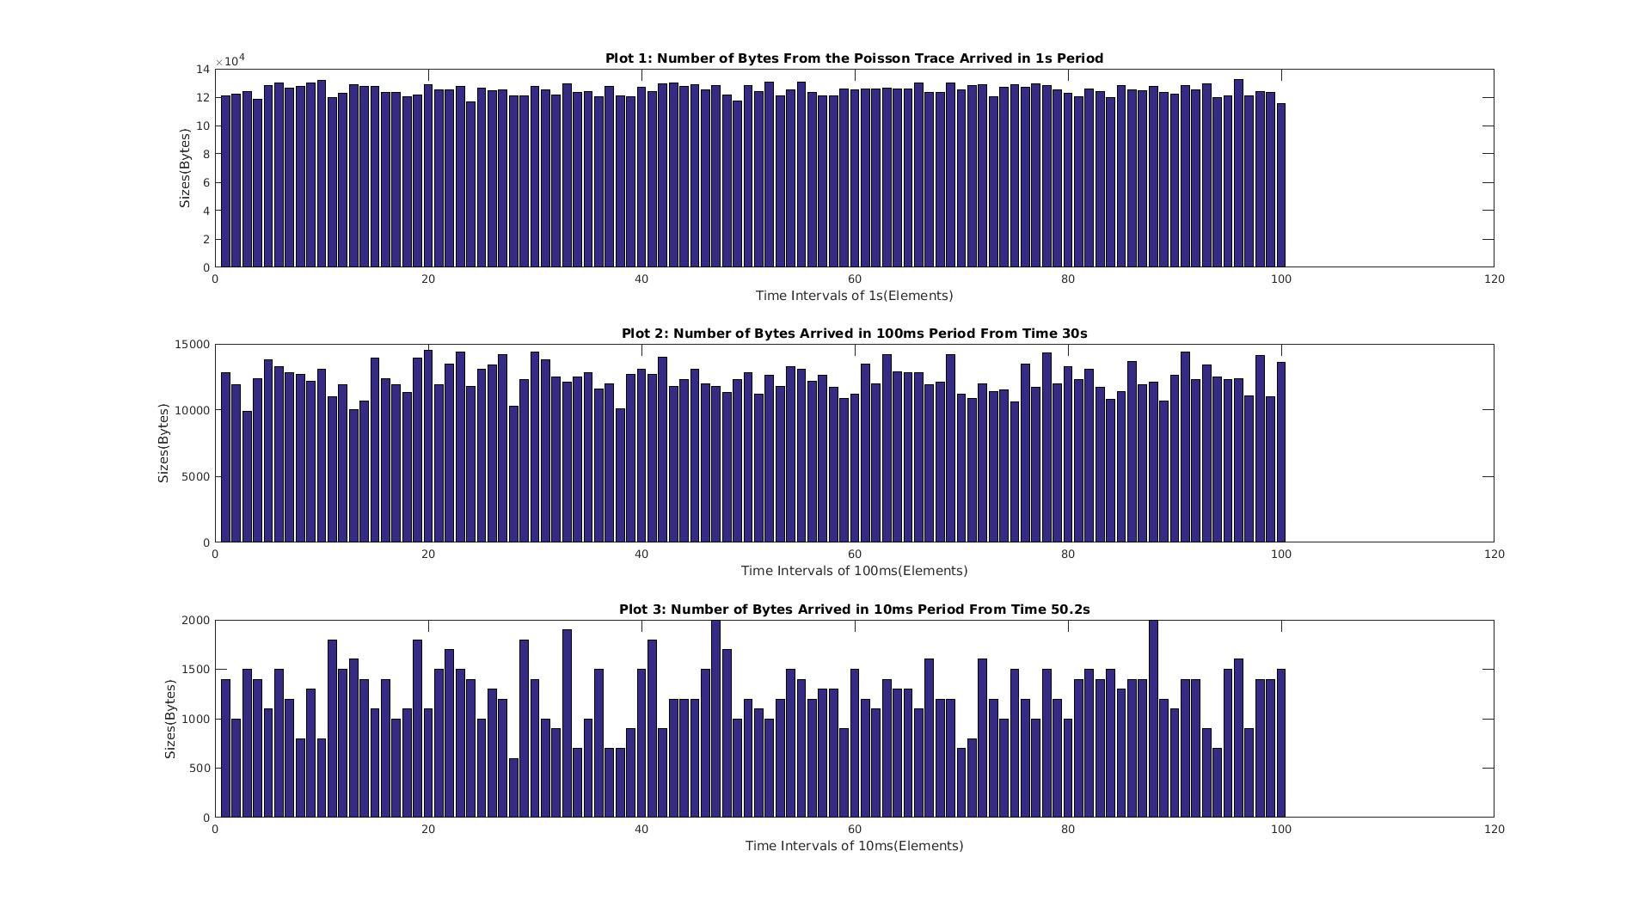

• Describe your observations of the graphs.

**The number of bytes fluctuates more when observed in smaller time frames, and remains almost unchanged when viewed in 1 second period.**

## **Exercise 1.3 Compound Poisson arrival process**

Now consider a packet arrival pattern of a flow, which is a combination of the previously discussed flows. Here, the packet arrival events follow a Poisson process with rate λ = 1250 packets/sec, and the packet size has an exponential distribution with average size 1/μ = 100 Bytes. The file poisson3.data contains a traffic trace of the data. Repeat the tasks in Exercise 1.1 with the above arrival flows.

• Verify the measured mean bit rate of the flow with the target rate, by calculating the mean and the variance of the times between consecutive arrival events. Compare the values with the theoretically expected values.

**Theoretically expected values:**

**Bit rate = 1Mbps**

**Arrival time = 800μs**

**Measured values:**

**Mean of time between consecutive arrival events = 795.2037μs**

**Variance of time between consecutive arrival events = 6.3184e+05**

**Mean bit rate = 1.0088Mbps**

**The expected and measure arrival time and mean bit rate are quite close. The high variance indicates that the data points are very diverse.**

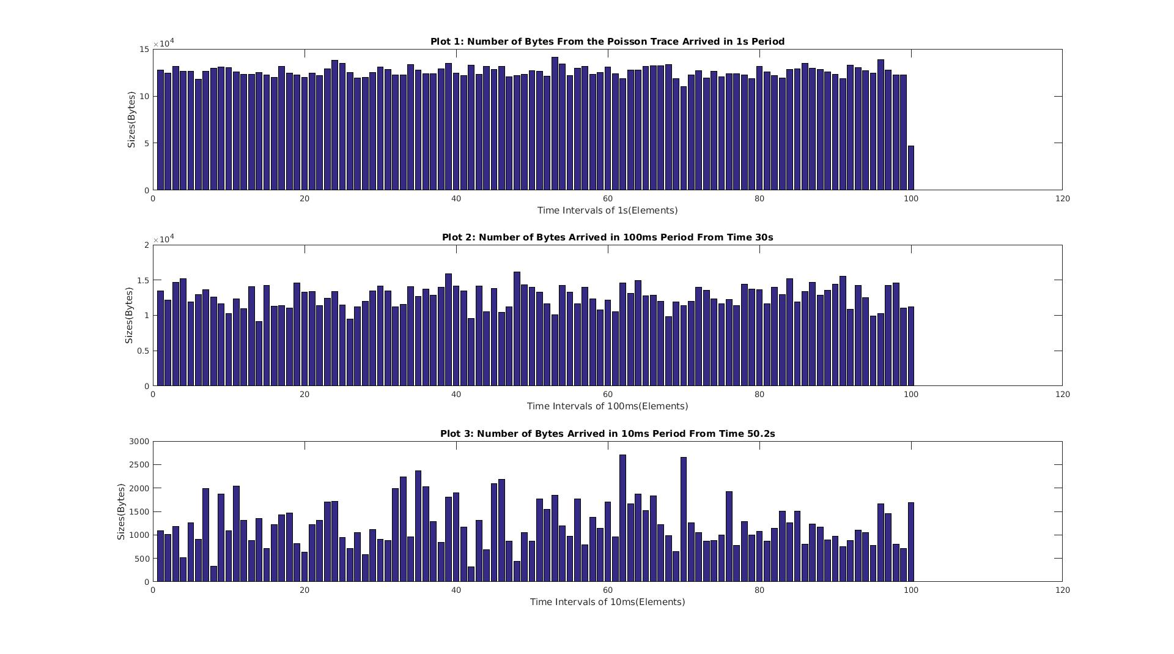

• Provide a discussion where you compare the results, with those of the other exercises.

**The plots look very similar to the plots in exercise 1.1 that packet sizes become more bursty when the time scale becomes smaller. It can be observed that combining two poisson processes will still result in a poisson process.**

# **Part 2. Compressed Video Traffic**

## **Exercise 2.2 Determine statistical properties of the video trace**

• Compute the following properties of the video trace.

|  |  |
| --- | --- |
| Number of frames | 53997 |
| Total number of bytes | 3.2100e+09 |
| Size of the smallest frame | 136 bytes |
| Size of the largest frame | 657824 bytes |
| Mean frame size | 5.9447e+04 bytes |
| Size of the smallest I frame | 528 bytes |
| Size of the largest I frame | 657824 bytes |
| Mean I frame size | 1.8378e+05 bytes |
| Size of the smallest P frame | 152 bytes |
| Size of the largest P frame | 493176 bytes |
| Mean P frame size | 1.1141e+05 bytes |
| Size of the smallest B frame | 136 bytes |
| Size of the largest B frame | 368976 bytes |
| Mean B frame size | 3.6093e+04 bytes |
| Mean bit rate | 14.2673 Mbps |
| Peak bit rate | 157.8778 Mbps |
| Peak-to-average rate ratio | 11.0657 |

• Generate a set of graphs that show the properties of the video trace:

1. Generate a graph that shows the frame size as a function of the frame sequence number. (Use the sequence in which the frames are listed in the file, i.e., the transmit sequence.)

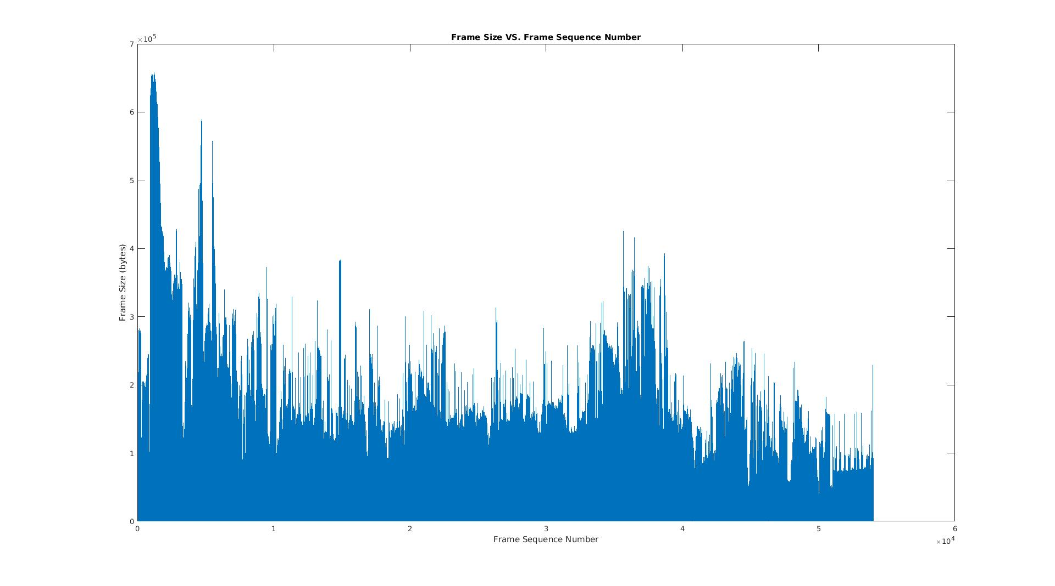

2. Generate a graph that shows the distribution of I frames, P frames, and B frames. (x-axis is the frame size, y-axis is the relative frequency).

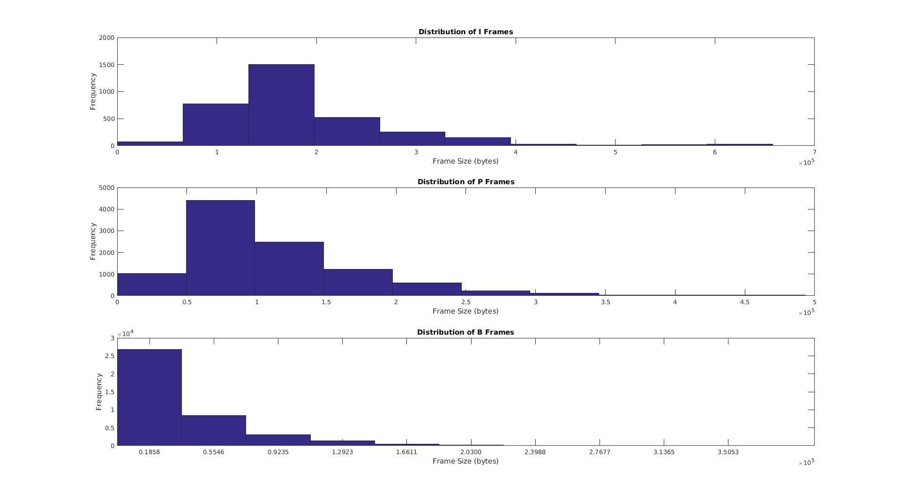

## 

## **Exercise 2.3 Scaling Video traffic**

• Create three plots of the video traffic trace viewed at different scales. Each graph has 100 data points.

• Plot 1: Generate a vector with 100 elements. Starting with Frame 1, each element stores the amount of data from 500 frames of the video sequence.

• Plot 2: Generate a vector with 100 elements. Starting with a randomly selected frame, each element stores the amount of data from 50 frames of the video sequence. Pick a random starting point, e.g., frame 3000.

• Plot 3: Generate a vector with 100 elements. Starting with a randomly selected frame, each element stores the amount of data from 5 frames of the video sequence. o Pick a random starting point, e.g., frame 5010.

• Plot the content of the vectors in three separate graphs, with the frame number on the x-axis, and the number of bytes on the y-axis. The data points should be depicted as vertical bars (e.g., using the MATLAB function bar() ).

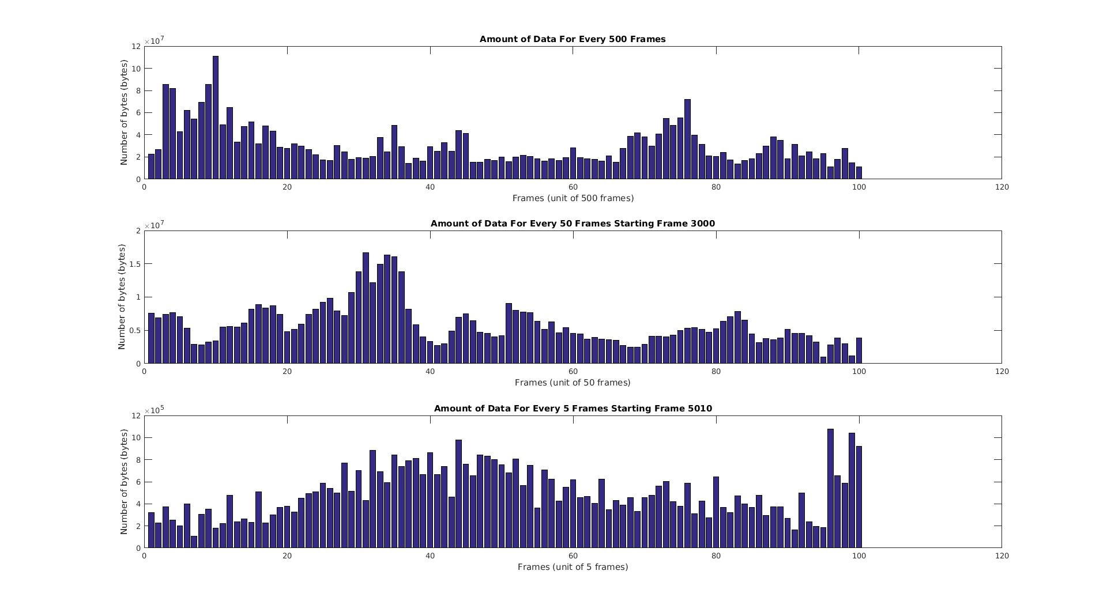

• Describe your observations of the graphs, and compare them to the scaled versions of the Poisson plots from Part 1.

**These three graphs are quite different from the ones in Part 1. Even when viewed in larger packet frames, the graph still has significant fluctuation. The pattern of video packets is more realistic than the ones from Part 1, it is not poisson traffic. The real internet traffic is fractal, just like the above plots.**

# **Part 3. Aggregate traffic on an Ethernet network**

## **Exercise 3.2 Determine statistical properties of the Ethernet trace**

• Analyze the trace of the Ethernet traffic:

|  |  |
| --- | --- |
| Number of captured packets | 1000000 |
| Total number of bytes | 434292031 bytes |
| Mean bit rate | 1.1055 Mbps |
| Peak bit rate | 43.b Mbps |
| peak-to-average | 39.3493 |

• Compute the ratio of the peak rate and the average rate to the peak-to-average rate ratio from the video trace in Part 2.

• Generate a set of graphs that show properties of the Ethernet traffic trace:

1. Generate a graph that depicts the packet size as a function of time. 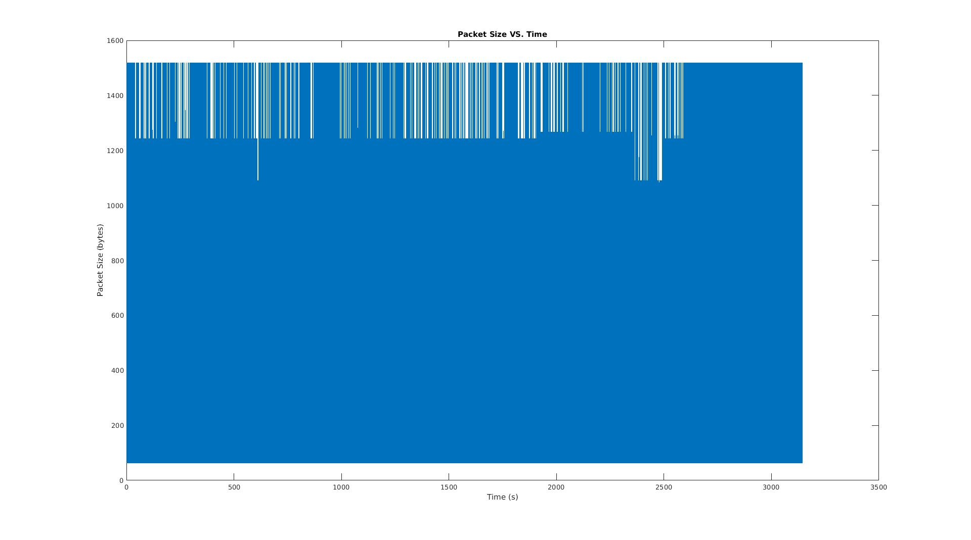

2. Generate a graph that shows the distribution of packet sizes (x-axis shows the packet size, y-axis shows the relative frequency).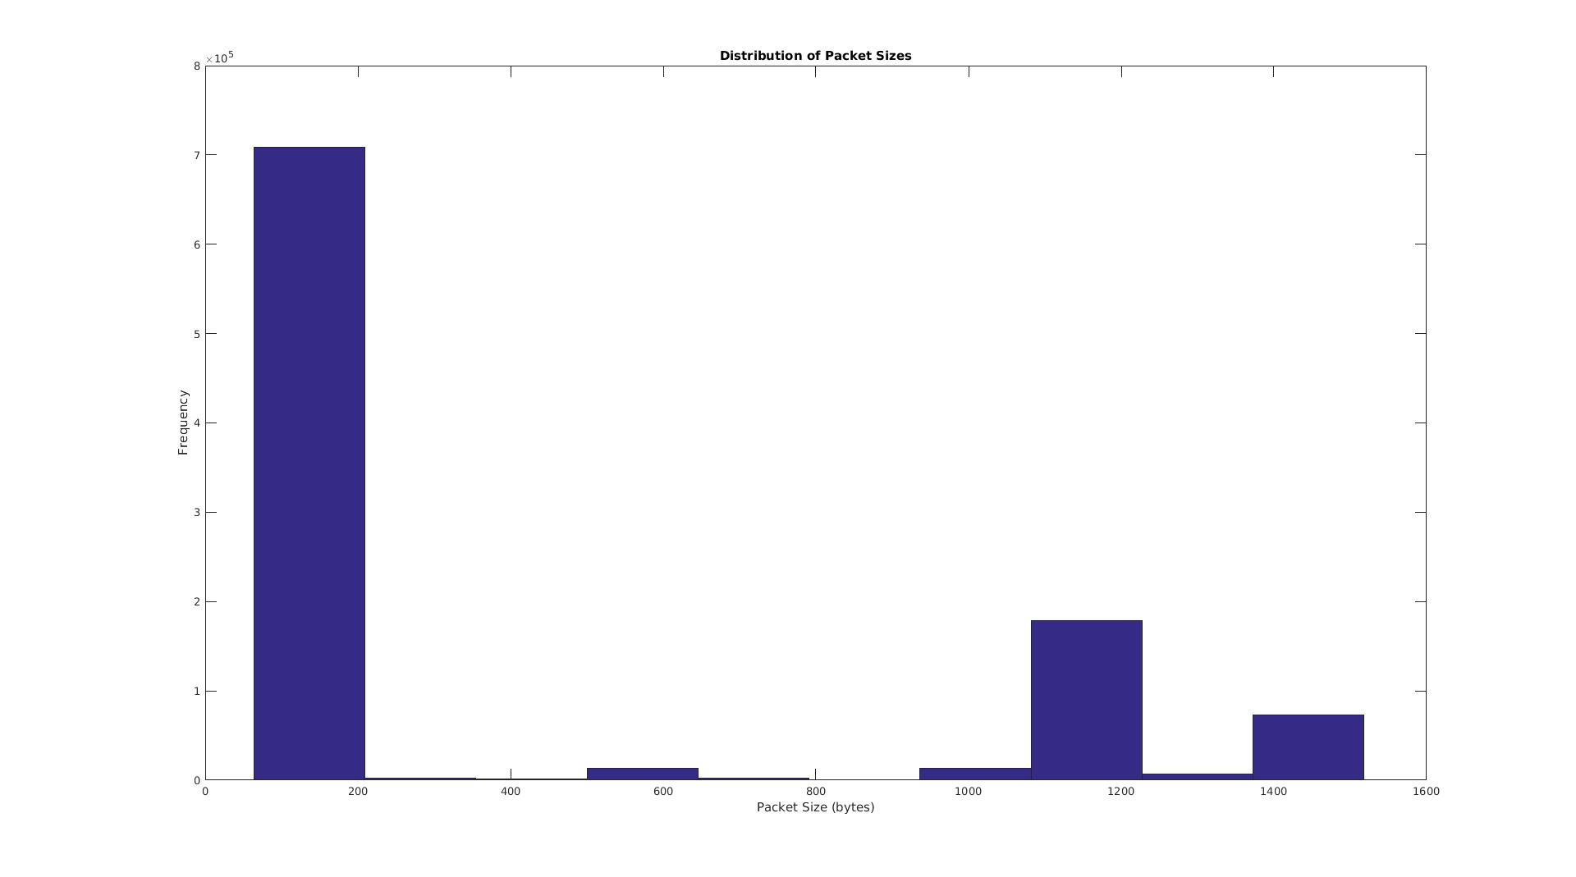

## **Exercise 3.3 Scaled depiction of Ethernet traffic**

• Create three plots of the Ethernet traffic trace viewed at different scales. Each graph has 100 data points.

• Plot 1: Generate a vector with 100 elements, where each element stores the amount of data captured in a 1 s interval.

• Plot 2: Generate a vector with 100 elements, where each element stores the traffic from 100 ms worth of captured traffic. Select a random starting time.

• Plot 3: Generate a vector with 100 elements, where each element stores the traffic from 10 ms worth of captured traffic. Select a random starting time.

• Plot the content of the vectors in three separate graphs, with the packet number on the x-axis, and the number of bytes on the y-axis. The data points should be depicted as vertical bars (e.g., using the MATLAB function bar() ).

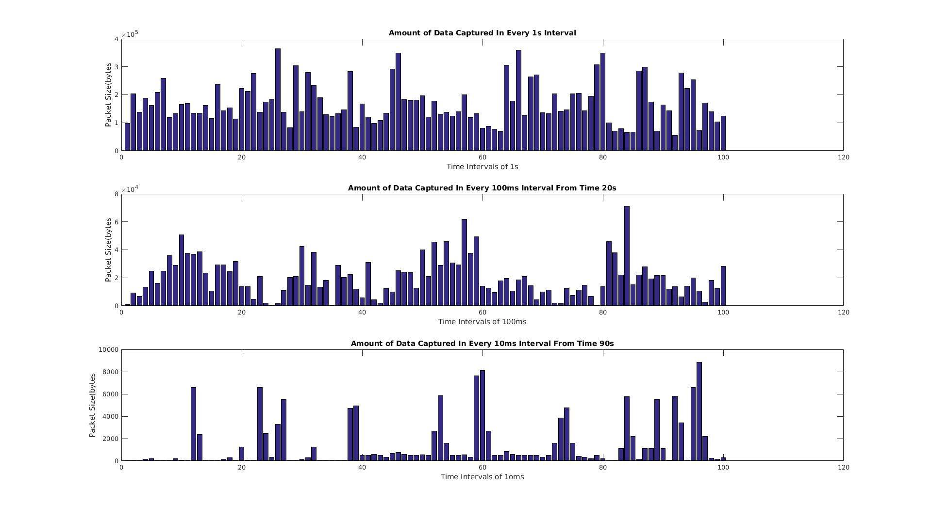

• Describe your observations of the graphs, and compare them to the plots from the Poisson traffic and the video trace.

**The Ethernet traffic trace does not follow a Poisson distribution. The packet size curve does not appear to be smooth when viewed under rough time scale. The three plots show a self-similarity that they look alike under different time scales.**